Machine Learning – 04

**Eigendecomposition of a matrix**

The Eigendecomposition of a square matrix is a factorization s.t the matrix is represented by its **eigenvalues and eigenvectors** (this concept is often called diagonalization of a matrix)

Let **A** be a square *n* × *n* matrix with *n* linearly independent eigenvectors *qi* (where *i* = 1, ..., *n*). Then **A** can be [factorized](https://en.wikipedia.org/wiki/Matrix_decomposition) as:

**A = Q Λ Q^-1**

�=���−1where **Q** is the square *n* × *n* matrix whose *i*th column is the **eigenvector** *qi* of **A**, and **Λ** is the [diagonal matrix](https://en.wikipedia.org/wiki/Diagonal_matrix) whose diagonal elements are the corresponding **eigenvalues**, *Λii* = *λi*

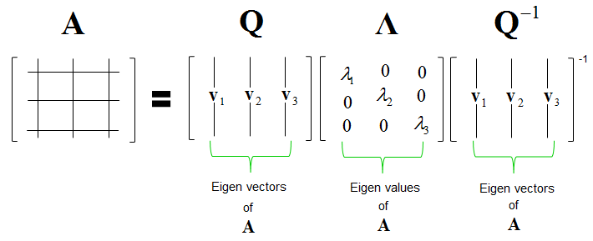Note that only [diagonalizable matrices](https://en.wikipedia.org/wiki/Diagonalizable_matrix) can be factorized in this way, trivially

**Remark:**

* The eigenvalues of a matrix can be found by **det(A - Iλ) = 0**
  + Where I is the n x n identity matrix
* The eigenvectors of a matrix can be found by substituting for each eigenvalue in the spectrum and computing **Ker(A-Iλ)**

Link : https://juanitorduz.github.io/the-spectral-theorem-for-matrices/

**Principal component analysis (PCA)**

PCA is used to reduce the dimensionality of a dataset (see overfitting – lack of generalization), using a transformation that preserves the most variance in the data using **the least amount of dimensions**

It in fact is assumed that the information is carried in the **variance** of the features, meaning that:

**Higher variation ⇒ more information**

We aim to follow these steps:

1. Construct the **covariance matrix**
2. Compute its eigenvalues
3. Use the eigenvectors to reconstruct data

This is useful in **unsupervised learning**

**Remark: The covariance matrix**

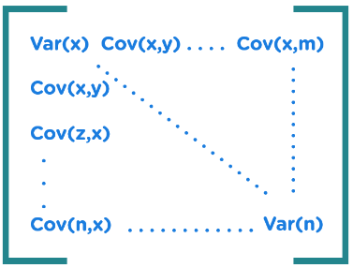The [covariance matrix](https://www.simplilearn.com/covariance-vs-correlation-article), a square matrix that displays the pairwise correlations between all pairs of variables in the dataset, is calculated in the setting of PCA using correlation

The covariance matrix's diagonal elements stand **for each variable's variance**, while the off-diagonal elements indicate the **covariances between different pairs of variables**

The strength and direction of the linear connection between two variables can be determined using the correlation coefficient, a standardized measure of correlation with a range of -1 to 1 (see first document)

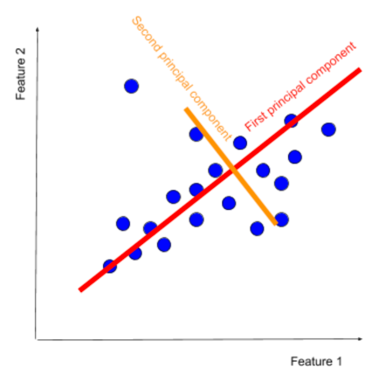The principal components are vectors, but they are not chosen at random

The **first principal component** is computed so that it explains the greatest amount of variance in the original features

The **second component** is orthogonal to the first, and it explains the greatest amount of variance left after the first principal component

PCA allows the representation of data as linear combinations of principal components

(in slides, X is the point that has to be flattened)

**Calculating principal components** (https://www.keboola.com/blog/pca-machine-learning)

1. 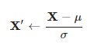**Standardize the data** (using Z-score)

Where **µ** is the mean and **σ** is the std deviation

1. **Build the covariance matrix**
2. **Calculate its Eigendecomposition**
3. **Sort the eigenvectors from the highest eigenvalue to its lowest**

The eigenvector with the highest eigenvalue is the first principal component

Higher eigenvalues correspond to greater amounts of shared variance explained

1. Text, letter

   Description automatically generated**Select the numbers of principal components** (this is dependent on the number of dimensions, for a plane it’s at most two)

**Singular value decomposition (SVD)**

SVD is a factorization of rectangular m×n matrix A as **A = U Σ V.T** where:

* U is an m×m **orthogonal** matrix with [Eigenvectors](http://mlwiki.org/index.php/Eigenvectors) of A A.T
* Σ is an **diagonal**m×n matrix with [Eigenvalues](http://mlwiki.org/index.php/Eigenvalues) of both A.T A and A A.T
* V.T is an n×n **orthogonal** matrix with [Eigenvalues](http://mlwiki.org/index.php/Eigenvalues) of A.T A

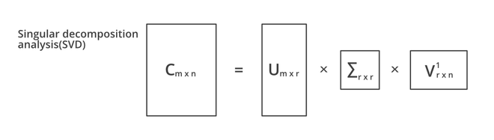(<https://jonathan-hui.medium.com/machine-learning-singular-value-decomposition-svd-principal-component-analysis-pca-1d45e885e491>)

